Web API Calling in GUI project (JavaScript file)

**Step-1:** Find Folder Static

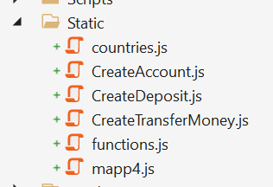

Step-2: Open CreateAccount.js file

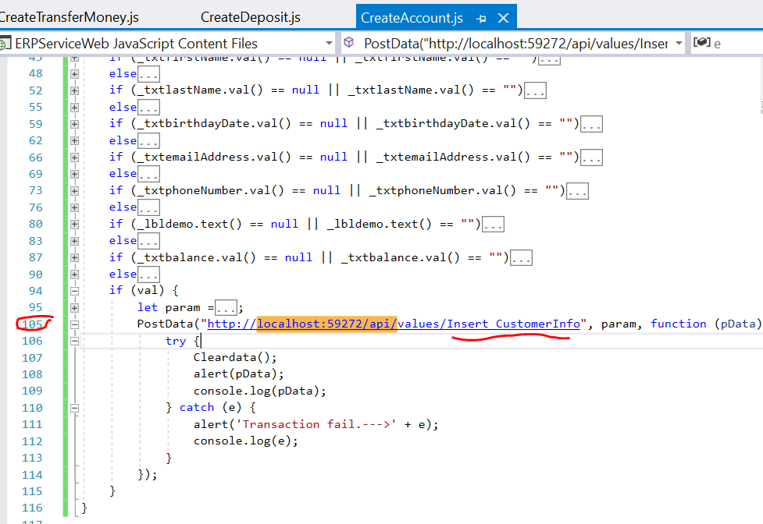

After download the Source code into your computer, run WEB API project and update (**localhost:59272**) WEB API URL here

Step-2: Open CreateDeposit.js file

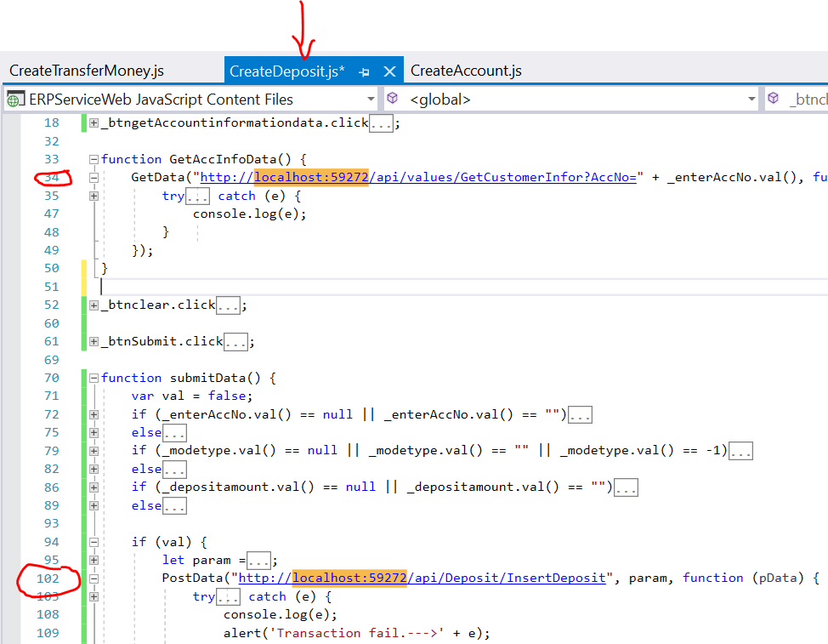

After download the Source code into your computer, run WEB API project and update (**localhost:59272**) WEB API URL here

Step-3: Open CreateTransferMoney.js file

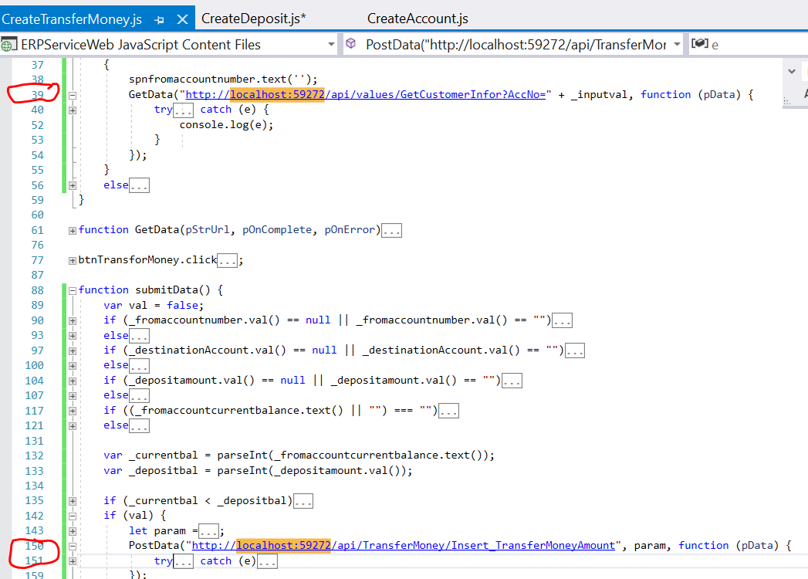

After download the Source code into your computer, run WEB API project and update (**localhost:59272**) WEB API URL here